I

In 8th Grade Classrooms, we will work with students and their families to support students’ success in reading, mathematics, science, and social studies utilizing research-based strategies. Some of our key connections with families will be to:
Mathematics

Understand the concept of functions
Interpret and build functions
Solve one variable equations and inequalities
Interpret linear models
Use descriptive statistics

Reading/Science/Social Studies
Analyze with strongest and most appropriate evidence
Evaluate arguments and reasoning
Identify irrelevant information
Read for comprehension and vocabulary
Solve Physical Science equations

In 6th Grade Classrooms, we will work with students and their families to support students’ success in reading, mathematics, science, and social studies utilizing Advancement Via Individual Determination (AVID) and research-based strategies. Some of our key connections with families will be to:

Mathematics

Connect ratio and rate to whole number multiplication and division and use concepts of ration and rate to solve problems
Develop an understanding of statistical thinking
Explain and manipulate the relationship between percentages, decimals, and fractions
Write, interpret, and use expressions, equations, and inequalities

Reading/Science/Social Studies

Compare and contrast genres
Understand and avoid plagiarism
Establish relationships among ideas
Compare and contrast text, film, and audio
Strengthen Informational Text Skills (Comprehension)

In 7th Grade Classrooms, we will work with students and their families to support students’ success in reading, mathematics, science, and social studies utilizing AVID and research-based strategies. Some of our key connections with families will be to:
Mathematics

Develop an understanding of proportional relationships
Understand what algorithms to apply to word problems
Develop an understanding of operations with rational numbers
Solve problems involving scale drawings and informal geometric construction
Draw inferences about populations based on samples

Reading/Science/Social Studies

Provide objective summary
Compare historical fiction to history
Acknowledge alternate/opposing claims
Preview points after stating topic
Address audience and purpose

Points of Pride:

W.S. Hornsby Middle School prides itself in the partnership and sponsorship from numerous community partners.
W.S. Hornsby Middle School students received Individual Math Competition Winners.
W.S. Hornsby Middle School student participated in the district spelling bee.
W.S. Hornsby Middle School students placed in various district competitions such as the Water Tower Competition where many students were recognized.
W.S. Hornsby Middle School HRRB Students placed 1st place in the district for three consecutive years.

W.S. Hornsby Middle School Students are…….

P.R.I.D.E.

Prepared

Respectful and Responsible

Independent Thinkers

Determined

Engaged

W.S. Hornsby Middle School

Jaguars
Making the Good….Great!
Every Student…..Everyday!

Jaguars Matter!
Restoring the R.O.A.R.
School Focus Initiatives: PBIS and RIGOR

Mrs. Stacey R. King, Ed.S., Principal
320 Kentucky Ave.
Augusta, GA 30901
Phone: 706-823-6960
Fax: 706-823-6963
24/25 Theme: Restoring the R.O.A.R.
Revision Date: February 29, 2024
Fax: 706-823-4372
Website: http://hornsby.rcboe.org
Richmond County School System

Learning Today… Leading Tomorrow

Teacher, Parents, Students & Stakeholders

Together for Success!
Revision: 02/29/24

School-Parent Compact
Jointly Collaborated
The Title I School-Parent Compact was jointly collaborated by parents/guardians, students, teachers, and faculty members. Each school year, meetings are held for parents/guardians, teachers, and students to compare the compact with school data and review our progress and assess our goals.


www.webaddress.com
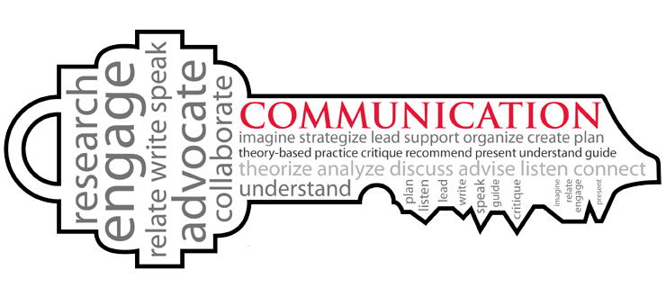
Goals
W.S. Hornsby Middle School Students

- Come to school on time, be prepared and ready to learn
- Get enough sleep/Eat a healthy breakfast
- Complete I-Ready and Reading Plus lessons with 80% accuracy
- Practice reading and math fluency daily
- Daily communicate and share learning opportunities with parents/guardians regarding their school learning experience

In our home we promise to…

Math

- Practice assigned math skills for 15 minutes each day
- Review concepts from the instructional school day
- Review areas of misconceptions
- Utilize FEV Tutor
Reading

- Have our child read daily for at least 15 to 30 minutes
- Offer support and guiding questions
- Visit the local library, obtain a library card, as well as use the school media center
- Monitor homework
- Utilize FEV Tutor
Happy Teaching & Learning

By May 2025, ELA, Science, and Social Studies teachers will implement evidence-based comprehension and vocabulary strategies to increase the percentage of students scoring at developing learner and/or above on the English Language Arts GMAS from 36% to 46%.

By May 2025, math teachers will increase student achievement from 40% to 50% on developing or higher on the iReady spring diagnostic using evidence based instructional strategies.

By May 2025, 90% of the students in grades 6th through 8th will maintain an average daily attendance rate of 92%. By May 2025, students in grades 6th through 8th will complete at least 24 Social Emotional Learning Lessons located in the panorama SEL and Canvas platforms.

By May 2025, we will increase the number of students with disabilities scoring developing and higher from 8% to 11% on the ELA Georgia Milestone Assessment and the number of students scoring developing and higher from ______ % to _____ % on math Georgia Milestone Assessments.
Parent-Teacher Conferences will take place as indicated on the school academic calendar.

Attend Monthly Parent and Child Time Meetings

Student Report Cards issued every nine weeks, in addition to progress reports issued every 4 weeks.

Notes and Flyers will be sent home to keep parents up to date on academic, extra-curricular activities, and student progress.

Visit the school’s website

Attend Volunteer Workshops

Parents are always welcome!
Please call the school to schedule an appointment with staff at (706) 823-6928.

Please refer to our Website regarding teachers’ Email information.
http://hornsby.rcboe.org/
Staff & Departments Directory

As a school, we will….
- Provide Family Academic Events and share researched-based strategies with parents/guardians to assist students
- Provide tutoring opportunities to assist in increasing academic achievement
- Keep school and teacher WebPages current with resources that can be utilized to reinforce concepts being taught in the classroom

As parents/guardians, we will….
- Be an active partner in my child’s education
- Attend workshops and academic opportunities to learn how to assist my child
- Reinforce skills that are taught at home
- Allow my child to attend tutoring sessions offered by the school and teachers
- Utilize school and teacher WebPages as well as resources with my child to increase academic achievement


0

During the 202 -2025 year, we will increase student content mastery in tested subject areas on the Georgia Milestones by 3%.

During the 2023-2024 school year, we will increase the number of highly effective teachers and leaders retained in RCSS by 3%.

Every student at Hornsby is educated as an unique individual. Each student is guided, nurtured, and inspired in a way that maximizes his or her potential- academically, culturally, and socially.
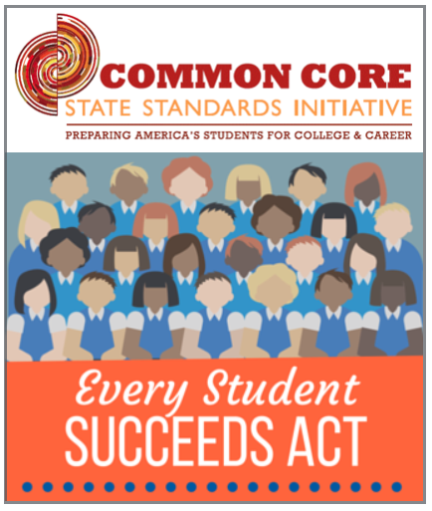
District Goals
Together We Will Succeed…
Yes, We Can!

The Parent’s/Guardian’s Responsibilities
Parents/families will guarantee regular practice of Math and Reading concepts to address their child’s specific learning target(s) and, with the assistance of the teacher, will monitor student growth. Furthermore, they will ensure their children attend school daily.

The Student’s Responsibilities
The student will use self-monitoring strategies, with the support of the family and assistance from the teacher, to assess his/her progress on achieving academic achievement goals/learning targets related to content vocabulary development.
STUDENTS

- Talk with family members about new concepts learned in all content areas from their instructional day

- Practice reading and math skills daily to build academic strength

- Participate in conferencing about progress and grades

